***Electrical Engineering Department***

***1st year of Communication***

***Electric circuits 2 (2017/2018)***

***Sheet (6)... Transient Analysis(P.1)***

1. *A series RL circuit with R=25 ohms and L=0.25 h has constant voltage 10 v applied at t=0 by the closing switch Find the complete solution for i.*

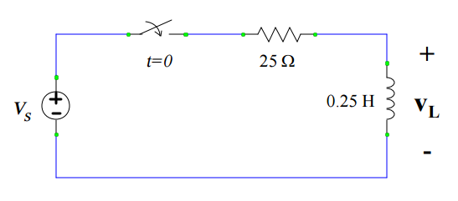

1. *In the RL circuit shown in Fig. 2 below, the switch is closed on position 1 at t = 0 and at t = 100 µsec the switch is moved to position 2. Find the resulting current in both interval*

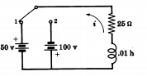

*Figure 2*

1. *In the series RL circuit shown in the fig , switch S1 is closed at t=0. After 4ms switch S2 is opened .Find the current in the intervals 0 < t < t1 and t1 < t . where t1 = 4ms*

**

1. ***A series RL circuit with R = 300 ohms and L =1 H has a sinusoidal voltage source v = 100 cos (100t + Ø) applied at a time when Ø=45. Find the complete current.***